Plants, Pollen, and People: Archeology and Pollen Analysis Student Handout

Vocabulary
Absolute dating: a scientific method used to estimate how old archeological objects are utilizing exact historical dates
Archeology: the scientific study of humans within the past
Archeobotany: the study of plant remains on archeological sites
Auger: a hollow, metal tool used to gather soil samples
Palynology: the study of ancient pollen
Pollen core: a sample of stratigraphic soil layers and the pollen samples within them
Pollen rain: the natural process of plant and tree pollen falling from the plant and being mixed into the soil
Radiocarbon/carbon-14 analysis: scientific method used to date organic archeological objects, such as wood and bone, utilizing the known decay rate of carbon-14
Relative dating: a scientific method to approximate the age of archeological objects in relation to each other
Stratigraphy: the scientific study of rock and soil layers

Introduction
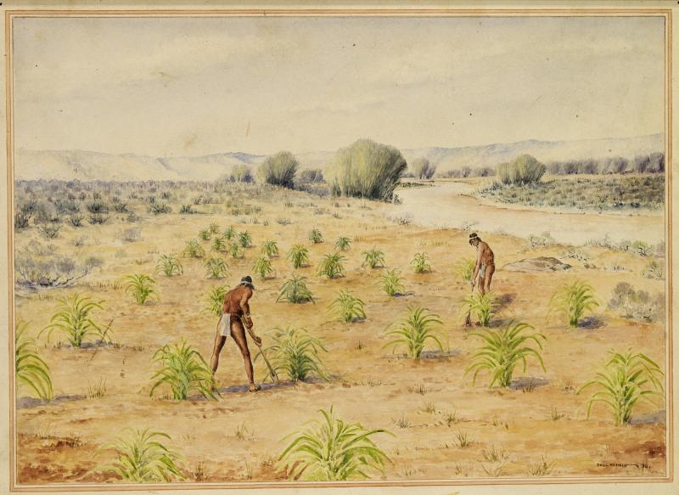
Native Americans planting crops. National Park Service.
Archeology is the scientific study of humans within the past. Archeologists use many scientific methods to understand ancient ways of life, including archeobotany, the study of plant remains on archeological sites. This includes palynology, the study of ancient pollen. Archeologists use pollen information to answer many questions about people in the past including:
- What kind of environment did they live in?
- Which trees were available for building materials?
- Which species of wild plants did they gather for food?
- Which types of plants did they grow and harvest?

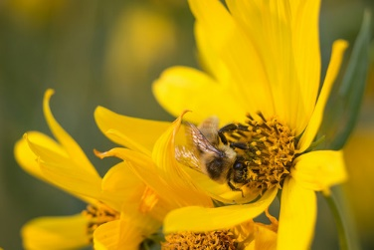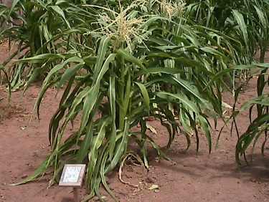
Bee pollinating flower (left) and corn crops (right). National Park Service.

Pollen Analysis
Plants and trees produce pollen that gets naturally blown from the plant, falls to the ground, and gets mixed into the soil in a process known as pollen rain. Over time, the soil builds up in stratigraphic layers, much like those of a cake, with the oldest soil on the bottom and the youngest on the top. Archeologists use this stratigraphy and the amount of different types of pollen within each layer to understand how plant populations changed over time.

Pollen Cores
Pollen analysis is a multi-step process. Archeologists must first obtain a pollen core that contains the stratigraphic soil layers and the pollen samples within them. An auger (a hollow, metal tube) is pushed into the earth to gather a sample that shows each soil layer in sequence. The deeper the auger goes into the soil, the further it is going back in time. Hand augers are used to gather shallow pollen cores while automated augers are used to go deep into the earth and see trends over hundreds or thousands of years.
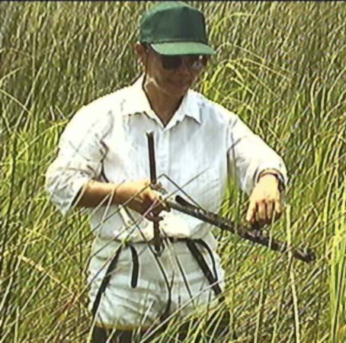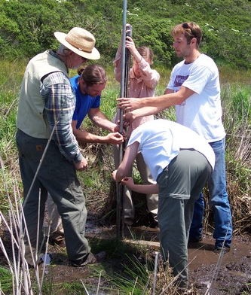
Researchers taking pollen cores. (Left: USGS; Right: National Park Service.)

Dating Cores
Soil layers. National Park Service.
Archeologists then date collected soil layers using both absolute and relative dating techniques.
Relative dating approximate how old soil layers are in relation to each other. In general, the deeper the layer of soil is in the ground, the older it is relative to the soil layers above it. For example, the dark gray soil in the below image is likely younger than the light gray soil but older than the brown soil.
Absolute dating methods such as radiocarbon (or carbon-14) analysis estimate specific dates. In this example, radiocarbon analysis might show that the light gray layer dates from between 1200 and 1300 CE (Common Era). Using relative dating, archeologists would then know that the overlying dark gray and brown layers would date from somewhere between 1300 CE and the present day.
Absolute dating methods are more precise than relative dating. However, they take time and can be expensive to perform. In contrast, relative dating is low-cost and allows archeologists to quickly understand trends.

Analyzing Pollen
After dating the soil layers, archeologists analyze the amounts of plant pollen contained within them. Pollen comes in many shapes and sizes and each species looks slightly different. Archeologists examine samples of each soil layer under a microscope to identify and count the number of pollen grains by plant species either by hand or with a computer program.

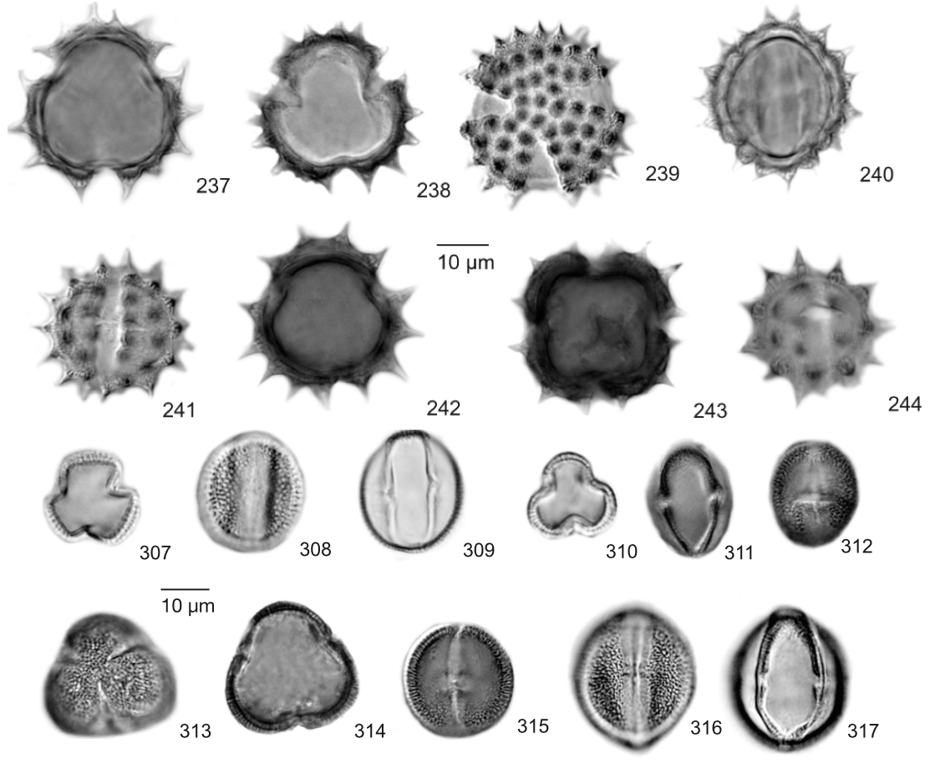
Diagram of different pollen shapes. (Adapted from Willard, Debra A., Christopher E. Bernhardt, and Lisa Weimer. Atlas Of Pollen And Spores Of The Florida Everglades. USGS.)

Graphing Data
Archeologists then graph their results to understand how each plant species population changed over time. They can also compare plant populations with one another. For example, they might notice that a tree species that thrives in wet conditions increases while one that does well in dry conditions decreases. From this information, they might gather that an area experienced an increased amount of rainfall.

Pollen seriation diagram showing an individual species (top) and comparing multiple families (bottom). (Adapted from Gennett, Judith A. and Richard G. Baker. “A Late Quaternary Pollen Sequence from Blacktail Pond, Yellowstone National Park, Wyoming, U.S.A.” in Palynology vol. 10 (1986):pp. 61-71.)

Interpreting Results
Archeologists use this data to interpret events within the past. These changes can be caused by both nature and human actions. For example, droughts, floods, or very hot or cold seasons can trees and plants to die. However, ancient people also cut down trees to build canoes, palisades, dwellings, and other structures. They also cleared the land to make agricultural fields. Both of these actions would have caused wild tree and plant species to decrease as well.
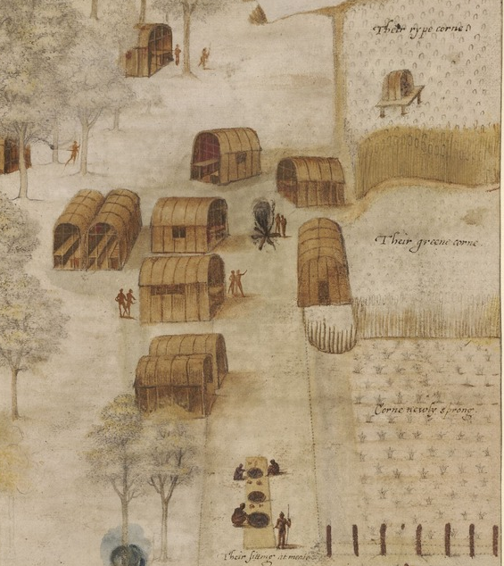
Artistic depiction of the Algonquin Secotan village. National Park Service.
Archeologists must therefore also use excavated artifacts, architecture, oral histories, historical documents, and other evidence to understand trends within the pollen data. For instance, they might find that past peoples lived in adobe structures instead of wooden ones or relied on hunting and gathering rather than agriculture. This information would help archeologists to decide whether human activities or environmental factors led to plant population changes. Overall, this data helps archeologists know what kind of environment past people were living in, what natural resources they had, and how they used and impacted these resources every day.

